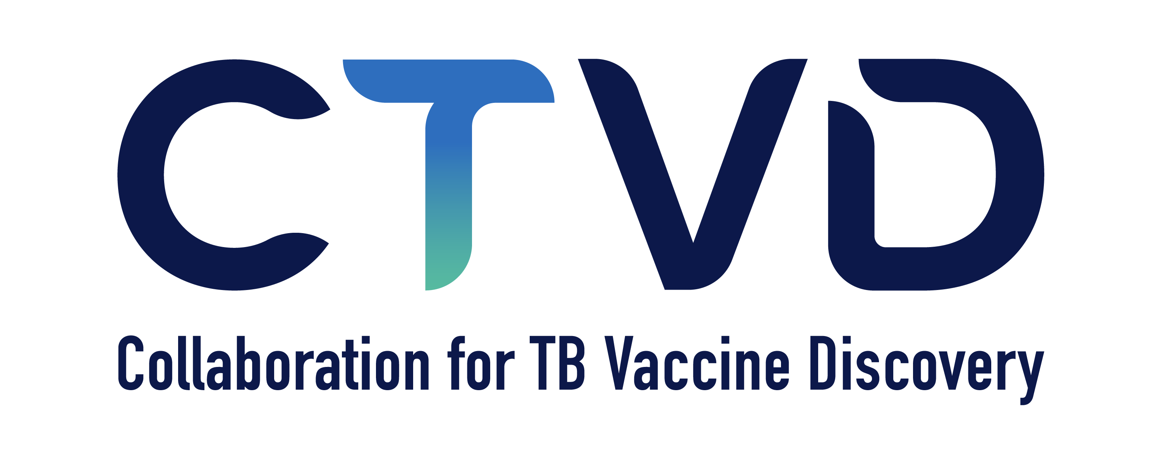

The 2026 Collaboration for TB Vaccine Discover (CTVD) Annual Meeting will be held in-person at the Hyatt Regency Nairobi Westlands in Nairobi, Kenya June 8-11, 2026. Research Community members and Early Career Researchers (ECRs) will meet June 8-9 and the scientific plenary sessions for all will convene June 10-11. June 8 is a half day (afternoon only), but June 9-11 will be full days, with a dinner reception each night. At this time, we are not planning to offer the meeting in a hybrid format.

As in years past, we will be offering travel awards for ~30 ECRs to attend the meeting and present a poster (the poster session will be held June 10); we regret this is the maximum number of ECRs we can accommodate. ECRs will have the opportunity to participate in a workshop on the afternoon of June 8 and the morning of June 9. A small subset of the ECRs will also be invited to give podium presentations during the plenary sessions of the annual meeting.

ECR Application Process for the Annual Meeting:
CTVD will offer travel awards to ~30 early-career researchers (PhD students, postdocs and junior faculty) to attend the CTVD Annual Meeting. The awardees will be chosen based on quality of original, unpublished work of the early-career scientist, in an area relevant to TB vaccine discovery and development, described in an abstract. Awardees present a poster at the CTVD annual meeting and several abstracts are also selected for an oral presentation during the meeting. Applications and abstracts must be submitted in English and should include a title, authors, affiliations and a narrative that is not longer than 500 words. Please do not include any figures. Applications are now open and will be due February 2, 2026 at 6am (PDT). Applications will be reviewed by the CTVD management team and awardees will be informed about their application status toward the end of February. You may complete the application form below and return it to Ksenia Koon (Ksenia.koon@gatesfoundation.org).

Eligibility
1. ECR applications are open to PhD students, postdocs, and early career researchers. Eligible candidates have obtained their degree in the last 10 years.
2. There is no cap on the number of individual entries submitted from an institution.
3. Data previously presented in a professional society meeting and published data is eligible, as long as there are new/unpublished results included in the application. Please disclose both the venue and the date of the presentation, and/or the publication at the time of submission.

If your application is selected, we will pay your air travel and hotel to attend the meeting. Because we have a hotel block and our travel team prefers to book air travel directly, please do not make your own travel arrangements. Please let Ksenia (Ksenia.koon@gatesfoundation.org) know if you have any questions on this process. We look forward to receiving your application!

CTVD 2026 ECR Application

Name:

Home Country:

Email:

Phone Number:

Institution:

Laboratory/Group Head:

What is your position?:

What is your highest degree?:

What is your degree date?:

Abstract Title:

Abstract (500 words or less):

Abstract Authors:

Abstract Affiliations:

Have you previously presented at a CTVD meeting? If yes, when?

Has your research been previously published? If yes, where?

Has this research been presented to a professional society meeting? If yes, where and when?

Please address any questions and return this completed application to Ksenia Koon, Ksenia.koon@gatesfoundation.org

